In [1]:

**import** numpy **as** np *# linear algebra*

**import** pandas **as** pd *# data processing, CSV file I/O (e.g. pd.read_csv)*

**import** matplotlib.pyplot **as** plt

**import** seaborn **as** sns

In [3]:

iris**=** pd.read_csv(r"D:\College\TE\SEM-2\Practical\DSBDA\6\Iris.csv")

In [4]:

iris.head()

|  |  |  |  |  |  |  |  |
| --- | --- | --- | --- | --- | --- | --- | --- |
| Out[4]: |  | | | | | | |
|  |  | **Id** | **SepalLengthCm** | **SepalWidthCm** | **PetalLengthCm** | **PetalWidthCm** | **Species** |
|  | 0 | 1 | 5.1 | 3.5 | 1.4 | 0.2 | Iris-setosa |
|  | 1 | 2 | 4.9 | 3.0 | 1.4 | 0.2 | Iris-setosa |
|  | 2 | 3 | 4.7 | 3.2 | 1.3 | 0.2 | Iris-setosa |
|  | 3 | 4 | 4.6 | 3.1 | 1.5 | 0.2 | Iris-setosa |
|  | 4 | 5 | 5.0 | 3.6 | 1.4 | 0.2 | Iris-setosa |

In [5]:

iris['Species'].unique()

Out[5]: array(['Iris-setosa', 'Iris-versicolor', 'Iris-virginica'], dtype=object)

In [6]:

iris.drop(columns**=**"Id",inplace**=True**)

In [7]:

g**=**sns.relplot(x**=**'SepalLengthCm',y**=**'SepalWidthCm',data**=**iris,hue**=**'Species',style**=**'Species g.fig.set_size_inches(10,5)

plt.show()

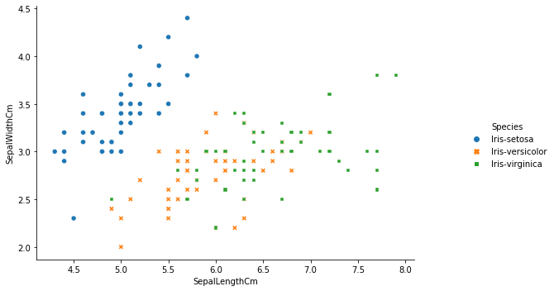

In [8]:

plt.figure(figsize**=**(15,10)) plt.subplot(2,2,1)

sns.violinplot(x**=**'Species',y**=**'PetalLengthCm',data**=**iris) plt.subplot(2,2,2)

sns.violinplot(x**=**'Species',y**=**'PetalWidthCm',data**=**iris) plt.subplot(2,2,3)

sns.violinplot(x**=**'Species',y**=**'SepalLengthCm',data**=**iris) plt.subplot(2,2,4)

sns.violinplot(x**=**'Species',y**=**'SepalWidthCm',data**=**iris) plt.show()

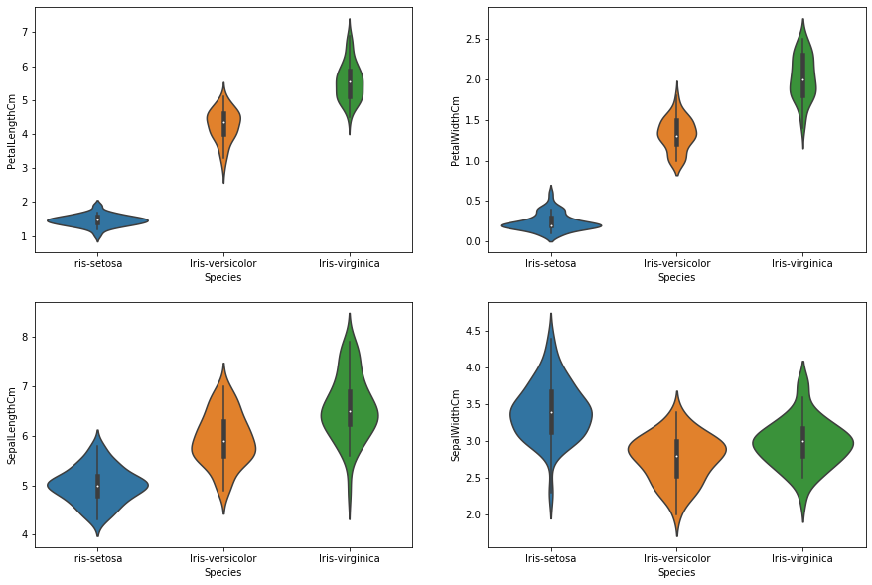

In [9]:

plt.subplots(figsize**=**(10,7)) sns.violinplot(data**=**iris)

sns.swarmplot( data**=**iris) plt.show()

C:\Users\HP\Anaconda3\lib\site-packages\seaborn\categorical.py:1296: UserWarning: 9.3% of the points cannot be placed; you may want to decrease the size of the markers or us e stripplot.

warnings.warn(msg, UserWarning)

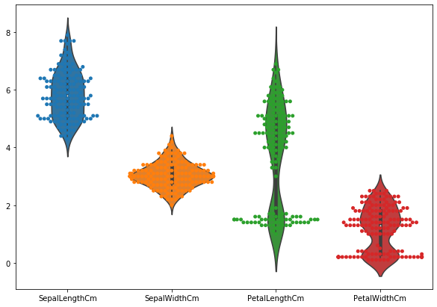

In [10]:

iris.plot.area(y**=**['SepalLengthCm','SepalWidthCm','PetalLengthCm','PetalWidthCm'],alpha**=**

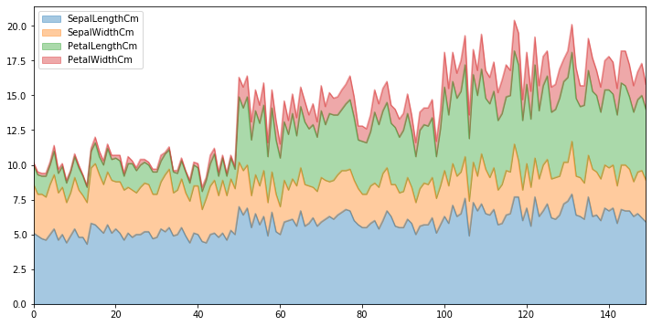

In [11]:

iris.corr()

|  |  |  |  |  |  |
| --- | --- | --- | --- | --- | --- |
| Out[11]: |  | | | | |
|  |  | **SepalLengthCm** | **SepalWidthCm** | **PetalLengthCm** | **PetalWidthCm** |
|  | SepalLengthCm | 1.000000 | -0.109369 | 0.871754 | 0.817954 |
|  | SepalWidthCm | -0.109369 | 1.000000 | -0.420516 | -0.356544 |
|  | PetalLengthCm | 0.871754 | -0.420516 | 1.000000 | 0.962757 |
|  | PetalWidthCm | 0.817954 | -0.356544 | 0.962757 | 1.000000 |

In [12]:

|  |  |  |
| --- | --- | --- |
| plt.subplots(figsize **=** (8,8))  sns.heatmap(iris.corr(),annot**=True**,fmt**=**"f").set_title("Corelation of attributes (petal plt.show() | | |
|  |  |  |

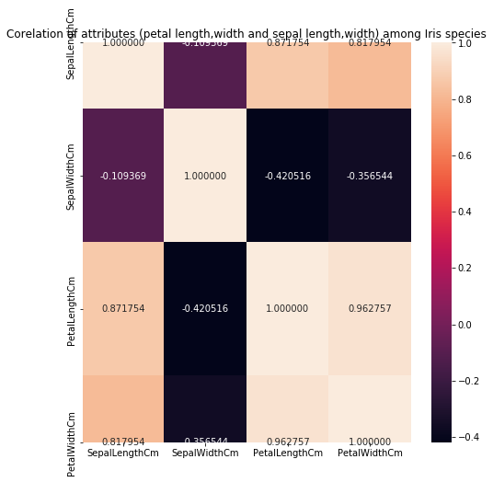

In [13]:

X**=**iris.iloc[:,0:4].values y**=**iris.iloc[:,4].values

In [14]:

**from** sklearn.preprocessing **import** LabelEncoder le **=** LabelEncoder()

y **=** le.fit_transform(y)

In [18]:

*#Metrics*

**from** sklearn.metrics **import** make_scorer, accuracy_score,precision_score

**from** sklearn.metrics **import** classification_report

**from** sklearn.metrics **import** confusion_matrix

**from** sklearn.metrics **import** accuracy_score ,precision_score,recall_score,f1_score

*#Model Select*

**from** sklearn.naive_bayes **import** GaussianNB

In [21]:

**from** sklearn.model_selection **import** train_test_split

In [22]:

*#Train and Test split*

X_train,X_test,y_train,y_test**=**train_test_split(X,y,test_size**=**0.3,random_state**=**0)

In [23]:

gaussian **=** GaussianNB()

gaussian.fit(X_train, y_train)

Y_pred **=** gaussian.predict(X_test)

accuracy_nb**=**round(accuracy_score(y_test,Y_pred)**\*** 100, 2)

acc_gaussian **=** round(gaussian.score(X_train, y_train) **\*** 100, 2)

cm **=** confusion_matrix(y_test, Y_pred)

accuracy **=** accuracy_score(y_test,Y_pred)

precision **=**precision_score(y_test, Y_pred,average**=**'micro') recall **=** recall_score(y_test, Y_pred,average**=**'micro')

f1 **=** f1_score(y_test,Y_pred,average**=**'micro')

print('Confusion matrix for Naive Bayes\n',cm) print('accuracy_Naive Bayes: %.3f' **%**accuracy) print('precision_Naive Bayes: %.3f' **%**precision) print('recall_Naive Bayes: %.3f' **%**recall)

print('f1-score_Naive Bayes : %.3f' **%**f1)

Confusion matrix for Naive Bayes [[16 0 0]

[ 0 18 0]

[ 0 0 11]]

accuracy_Naive Bayes: 1.000

precision_Naive Bayes: 1.000

recall_Naive Bayes: 1.000

f1-score_Naive Bayes : 1.000

In [ ]: